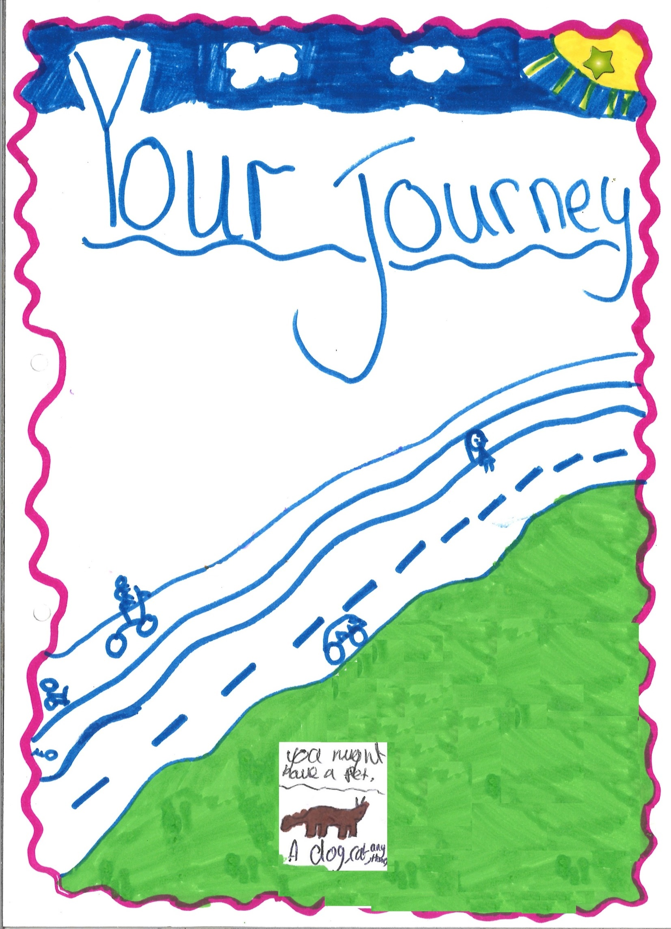
Living Away from Home

Contents Page

3. Hello from SiCC & SLCC!

5. Why are you living away from home?

5. Where are you going to live and who will look after you?

6. So what are the different types of places you could live?

7. Your education

8. Seeing your family, friends and other important people

9. Who is going to make sure you’re okay, support you and make decisions about you?

11. What can you expect whilst living away from home?

from SiCC & SLCC!

Hello from SiCC (Somerset in Care Council) & SLCC (Somerset Leaving Care Council), we are a group of young people who are in care (children looked after) and who have left care (care leavers). We have written this guide for you, to let you know everything you need to know about living away from home. If we’ve missed anything or you have any questions, you can ask your social worker. They should have given you a contact card with their name and number on, if you haven’t received this make sure you ask them, in the meantime the people looking after you will have their contact details.
You can also watch our film www.somerset.gov.uk/yourjourney

If you are feeling a bit unsure and you want to speak to someone else about living away from home, you can always call the Care Advice Line, they can talk to you about the many questions you may have about being in care. Just be aware these people will not know anything that is personal to you, like why you are in care. Freephone 0800 023 2033 (between 10am – 5pm, Monday to Friday)
or email advice@becomecharity.org.uk

For other helpful contacts please see our website pagehttps://www.somersetincarecouncils.org.uk/signpost/ and remember to watch our film www.somerset.gov.uk/yourjourney

Being in care can be confusing and it can be hard to make sense of.
You will probably have a lot of questions in your head like; will I be going to school tomorrow? Will it be the same school? How will I get there and who will collect me? Will I see my friends and family? Will I have to tell anyone I’m in care? Who is going to look after me and make sure I’m okay? Who will make the decisions about my life? Will I get my belongings and how will I get them?

The “local authority” (Somerset County Council) want to cause as little confusion to your life as possible, they will try to keep you close to home so that you can still go to the same school, see your friends and family and continue to go to any clubs and activities. If you end up living a long way from home the local authority will help you to stay in touch with the people who are important to you, they will make sure that you can get to school and any clubs and activities that you may be a part of.

We have done our best to answer as many of the questions you may have in the following sections. We have given each section a heading to make it easier for you to find the information you want and the answers to your questions.

Why are you living away from home?

So why are you living away from home? Well not all children and young people can live at home and there are many different reasons for this. The reason why you are not living at home will be personal and sensitive to you but we don’t need to talk about this now. There are two ways that you can become a child looked after,

You can be “accommodated”, this means that the council and your parents have agreed that you should be looked after; this is known as a section 20. This means that your parent/s have something known as parental responsibility, they have to make the decisions about you and your life.

Sometimes a court decides that you should live away from home because they think this is best for you, this is known as a “care order”. When on a court order the local authority will make decisions about you and your life and will share these with your parents.

If you have any questions about why you are in care, make sure you speak to your social worker.

Where are you going to live and who will look after you? –

When you are unable to live at home all the time, there are many different people who might look after you, these could be

- Family friends or people who know you well
- A relative
- A foster carer
- A children’s home
- A residential school
- Specialist homes for children with disabilities

There are many different places (also known as placements) where you could live, Somerset County Council; also known as your Corporate Parent, make sure that the place where you are going to live is a safe place for you. When deciding where you are going to live, your social worker will listen to what you want and how you are feeling about the decision. Your social worker will try and keep you close to your school, friends and family. The law says that the Local Authority should do all it can to make sure brothers and sister always live together, unless there is a very good reason why this should not happen. When it is not possible for brothers and sister to live together, the reason should be explained to you and plans need to be made to make sure you are able to remain in contact.
So what are the different types of places you could live? –

Foster care – this is where you live and are cared for by a family or person that have been okayed as foster carers by Somerset County Council, foster carers can also be friends and family members. Most children looked after in Somerset live in foster care.

Kinship care – where you live and are cared for by relatives

Respite care – is where someone else cares for you for a short time, so you, your carer or family can have a break/rest

Residential Care – is where you live in a children’s home. The home is staffed by a group of people known as residential support workers. You will have your own bedroom and a key worker who will help you to look after your day to day needs.

Residential School – or boarding school is where pupils live and study during the school year.

Leaving Care Accommodation – you will only live in this type of placement if you are over 18. You can find out more about the types of accommodation available when you receive your Leaving Care Guide.

Your education

Your education is important to Somerset County Council and they want you to do well, they want the same for you as they would their own child. Therefore, they will help you to make the most of your education, making sure you get the right help at the right time so you can become the best you can be. People involved in your education should have “aspirations” for you and your future.

Your education will be a priority when your social worker is planning with you and your carer.

If you move and end up living a long away from your school your social worker will try to keep you at the same school if that is what you want. Your social worker will make sure you have a way of getting there; this could be your carer, a voluntary driver (these are people that Somerset County Council have said are safe to drive you to places), a taxi or a public or school bus.

In every school there is a “designated teacher” for children looked after; their job is to support you. They are responsible for making sure you have a Personal Education Plan also known as a PEP. At times you may feel like you have a lot going on outside of school, which can make it difficult to concentrate. A designated teacher’s job is to understand the difficulties you may be experiencing and help you through them, so you can do well in your life and education.

What is a personal education plan (PEP)? –

Your personal education plan, is a plan that’s tells everyone involved in your care how you will be supported through your education. It will detail your progress and achievements, as well as any extra support you may need. It is your opportunity to say how you feel about your education and what you want to do in the future. PEP meetings are held every term and you should play a big part in the meeting because it’s your meeting. Your PEP will form part of your care plan.
In Somerset we have something known as the virtual school, the virtual school is not a real school with buildings and classrooms, they are a group of people who work for the local authority (Somerset County Council). Their job is to work with your school to make sure you enjoy school and do as well as you can. They work closely with designated teachers, social workers, teachers and others involved in your education giving them advice and support to make sure your PEP is as helpful as it can be.
If you want to find out more about the Virtual School, you can check out their website @ www.somersetvirtualschool.co.uk/young-people/ or ours (SiCC & SLCC) @ www.somersetincarecouncils.org.uk/
Seeing your family, friends and other important people

We know that staying in touch with your friends, family and other people in your life is probably really important to you but there may also be people who you do not want to stay in touch with, that’s okay too. What you need to know is, that when you are in care, you are still able to see your family, friends and other people who are important to you as long as it is safe to do so. Your social worker and carers must take into account your wishes and feelings about who you are in contact with at all times and they will do everything they can to make sure you remain in contact with all the people you want to.

The law says that local authorities have a responsibility to allow ‘reasonable’ family time between you and your parents. But sometimes people do not agree on what ‘reasonable’ means. When this happens a court can be asked to make the rules.

Family Time (being in touch with your family) will happen, if you and your family want it to happen and it is safe. How this happens will depend on how you are looked after.

- If you are accommodated then visits and contact with your parents and other relatives will be worked out and agreed with you, your parents, your carers, Social Workers and other people who are involved.

- If you are on a care order, the court will have also thought about how you should stay in touch with your family and friends. Children's Social Care must make sure that you have the contact as agreed in court. This is your right.

Myth Busting
Being in care does not mean you are a naughty child.
Myth Busting
Being in care does not mean you will not be able to do the things other young people do.
Who is going to make sure you’re okay, support you and make decisions about you?

There are lots of people who will support you while you are in care, you can contact these people; if you have a worry, if you want help with something, if you have any questions or would just like a chat. They are all here to help you.

Social Worker –
You will have your own social worker, they will get to know you well and understand all your needs. If you have a brother or sister in care you will usually have the same social worker. Your social worker’s job is to be responsible for all aspects of your day to day life in care; this includes your health, education and general wellbeing. They will; listen to you, involve you in all the meetings about you, the decisions that affect your life and any plans about you, they will include your wishes and feelings in your care plan. They will explain decisions and help you understand why they have been made. They will make sure you know how to get your voice heard. You should always have your social worker’s contact details. Your social worker will work with you until the age of 18 if you remain in care.

Independent Reviewing Officer (IRO) –
If you are in care you will have an independent reviewing officer until you are 18 ½. Their job is to chair your review meeting and make sure that any decisions that are made are in your best interests and are acted on. If you have siblings that are also in care they should have the same IRO as you. They will visit you before your review meeting and make sure that your views and feelings are listened to. They will stand up for your rights and make sure you know how to make a complaint if you are not happy with the way you are being cared for. Your IRO will monitor the local authority’s decisions and make sure that you get heard and are involved in the planning of your care.

Leaving Care Worker –
You will be allocated a leaving care worker by the age of 17 and a half years at the latest. They will keep in regular contact with you and help you to get into education, training and employment. They will provide you with advice on things like money, housing, staying healthy and support your move to independence. Your leaving care worker will act as a source of advice and will support you until the age of 21, this is extended to your 25th birthday if you remain in education.

Advocates -
An Advocate makes sure your views and feelings are heard and that you feel fully involved in decisions that are being made about your life. They make sure that people who make decisions about you are meeting your rights.

Advocates can also help you speak up for yourself or put your views across for you. An Advocate can go to a meeting with you, or go on your behalf and can support you with making and resolving a complaint. Ask your Social Worker about advocacy or see the leaflet in your pack.

Become, the charity for children in care and young care leavers, have put together a really useful fact sheet explaining the people and workers you might meet in children’s social care; from the Director of Children’s Services to Team managers. The fact sheet explains what everybody does and what you can expect from them. You can find this on our website; www.somersetincarecouncils.org.uk/whos-who-in-the-care-system/
Our website is also packed with loads of other useful information, such as explanations of all the confusing words that are used in children’s social care. The website is also your opportunity to get involved. You can request to join us at SiCC & SLCC or ask what certain things mean and read up on our meetings.

What can you expect whilst living away from home?

- When you are looked after you will have something known as a “review meeting”. This is where the people who are important to you come together to talk about your living arrangements, the plans for you and if they are working and if anything needs to be changed. Your social worker will visit you before your reviewing meeting to ask you who you want at your review meeting, where you want it to be held and what you want to talk about. The review meeting is your meeting and it is important that you have your say. Your social worker will meet with you before your review to find out the things you want to talk about and how you are feeling. You do not have to have everyone in the same meeting. Your review can be several meetings & you can choose which one you attend.

- The place where you live will be clean, warm and comfortable.

- You will usually have your own bedroom if you live in a foster care but definitely in children’s home (unless the children’s home is a school in which case you may share a room). You will only share a room with another child in foster care if you have said it’s ok. If you are not happy about where you sleep you can tell your carer and they will change it if they can.

- Your carer will make sure you go to school and will be there to help you with homework. Your carer will make sure you have the things you need for school, like uniform, books, pens and pencils. They will attend your parents evening with your teachers. Your social worker will do everything they can to try and keep you at the same school, if this is what you want. The government has introduced a law which says that you shouldn’t move school when you’re in year 10 as that could affect your GCSEs, unless there is a really good reason.

- You should have a say in the food you eat, and you will be encouraged to help shop for and make your own meals, when you are old enough. If there’s anything you cannot eat because of your religion or health, you won’t have to. Any special food you need will be given to you. Your carer will help you to make sure you are eating a healthy diet.

- You will be given some pocket money: all young people looked after by Somerset County Council, get pocket money. How much you get depends on how old you are.

- Your carers will be given money for your clothes and the other things you need, which you should be allowed to choose. They are also given some money to buy you presents for your birthday and other special occasions, depending on your culture.

- Your carer will help you plan and celebrate Birthdays, name days, Hanukkah, Ramadan and other festivals important to you.

- You are allowed to bring your own personal things into your new home, which is important because having your own stuff around can help to make a new place feel more like home. You should be provided with suitcases and bags for your belongings, the law says your things should never be moved in black bags.

- Your carer will pay for and help you with your hobbies, interest and activities like afterschool clubs and sport clubs. If you were doing these before, they will help you to carry on with these. Or you may want to try some new hobbies & interests, your carers will help you.

- Your carer will make sure that you go to a doctor, dentist, and nurse when you need to and make sure you visit an optician to have your eyes tested every one to two years, or more if you need to. If you have any questions or worries about your health – and this includes your mental health, like feeling sad or wanting to hurt yourself, then you must talk to your carer, social worker or any other adult you trust so that they can help you. You will also be offered a health check every year.

- Your carer will listen to your feelings and what you want, and try to help you. Generally, your carer will decide if you can stay overnight at friends’ houses (just like any good parent would). If there are worries about keeping you safe then your social worker or sometimes a court will have to decide, what to do.

- You must be given a say in the decisions that affect you, and you should be told about any decisions and changes to your care, and the reasons for them.

- You should be able to talk on the phone to members of your family in private, as long as it is safe for you to do this. Visits can also be arranged with family members at times that your carer agrees to.

- Your carers must never hit, slap or shake you, or harm you in any way.

- You should never be bullied by an adult or another young person while you are in a foster home or a children’s home, if you are, you need to tell an adult in charge as soon as possible so they can help you.

- Children’s social care must keep information and records about every young person who is looked after, this is generally referred to as your file. Any reports prepared on you should be discussed fully with you. You can ask to see your file; all children and young people have a right to do this

