SiCC & SLCC Meeting 11th November 2018

Attendees: Aaron, Becca, Charlie, Chloe, Holly, Jess, Josh C, Josh R, Josh S, Kaci, Katie, Morgan, Roxanne, Ryan, Tish, Jaycee (16)
Agenda Created By: SiCC + Lesley
Supporting Adults: Fi, Gary, Lesley,
Visitor : Liz Pearson & Helen McDonald, James Dean (JS), Bethan Williams

1. | Introductions | Action
 | All introduced themselves by saying their name, what they did and why they were at SiCC.  Some of the reason the young people gave for coming to SiCC & SLCC included; making new friends, to have their voice heard, to make a change for other young people in care and care leavers, to change the care system, to change theirs and other lives, to change people’s views of the care system and to be involved with a group. | Lesley to add these to the SiCC / SLCC page on the website.
2. | Youth Parliament
 | Fi briefly spoke to the group about Youth Parliament and how they can put themselves forward to be a Member of Youth Parliament. Two young people were interested in this. | Lesley to forward self-nomination forms to Kate Darlington
3. | Health Assessments Leaflets for CLA
 | Angela Reece show the group 3 leaflets, in groups the young people looked at the feedback and provided Angela with feedback. | 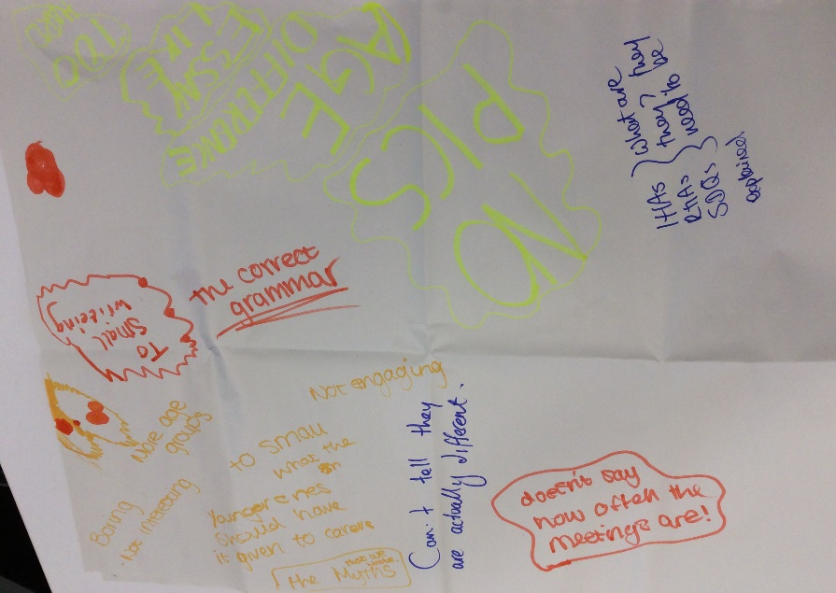  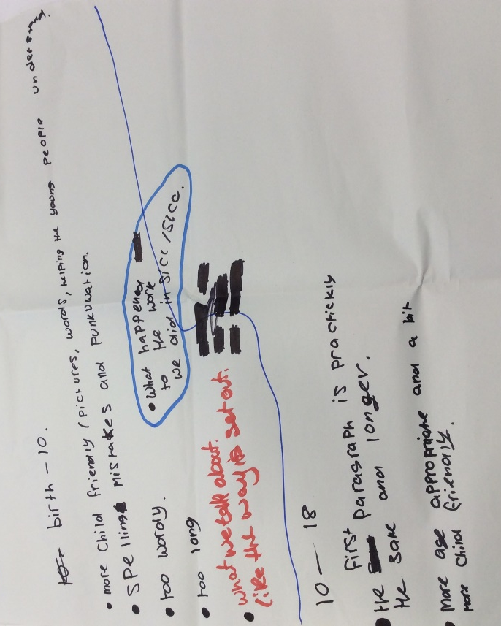
4. | Activity
 | Everyone took part in the mummy game. 4 minutes to make the best mummy by wrapping a member of their group in toilet paper.
5. | CLA Reviews
 | Last month the group asked to look at CLA reviews as they said they weren’t good or enjoyable. Lesley invited Liz Pearson (IRO manager) so she could hear what the group had to say and talk with them directly to gain their views. Young people looked at the invites that they are sent and gave their feedback as well as discussing the meeting itself, the ‘Having Your Say leaflets’ and the Outcomes that they are sent afterwards.  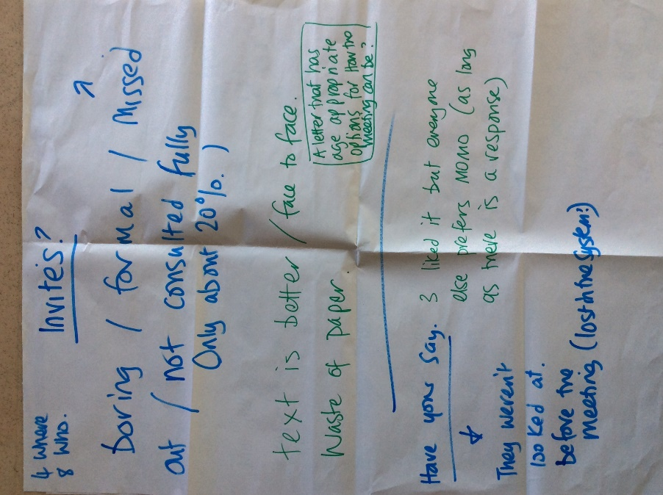  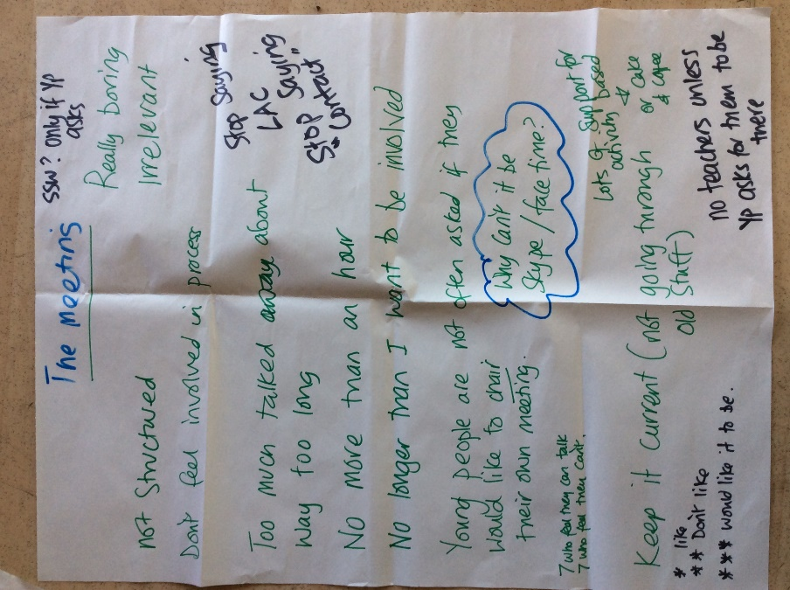  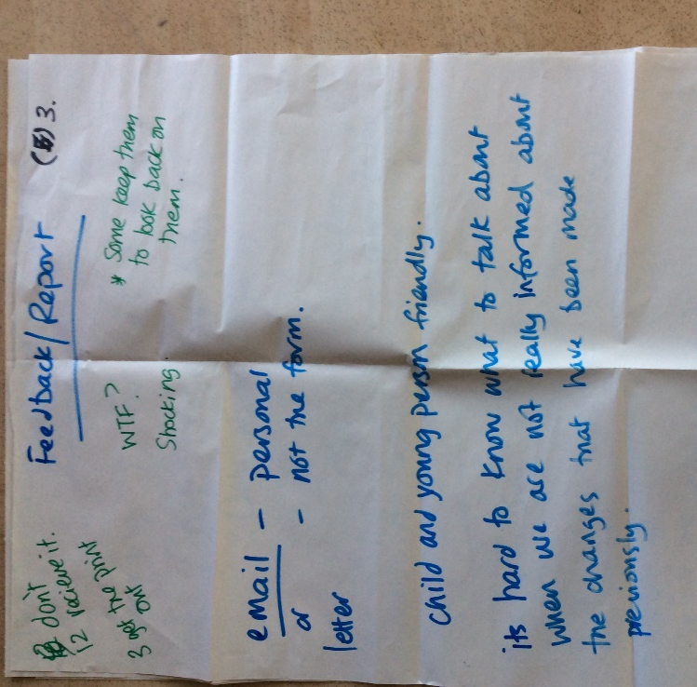  Young people were then given a lightbulb to write down how their review would look if they could choose how they would like then to be done. The general feeling was it should be a ‘meet up not a meeting’. Young People suggested things such as a walk n talk, Skype calls, going for something to eat, cake and coffee, ensuring their voice was heard, some young people highlighted that they have never been to their CLA review.  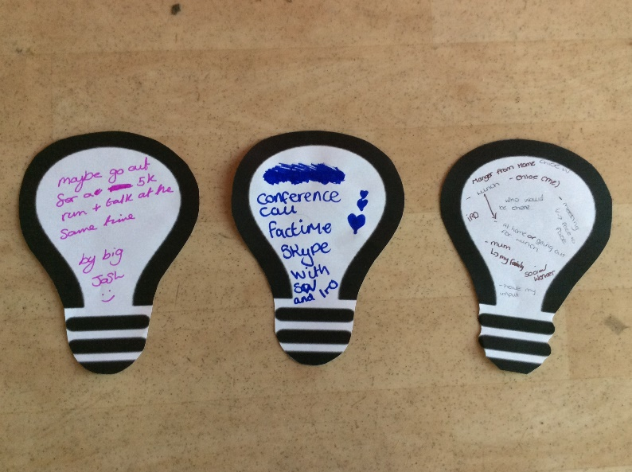  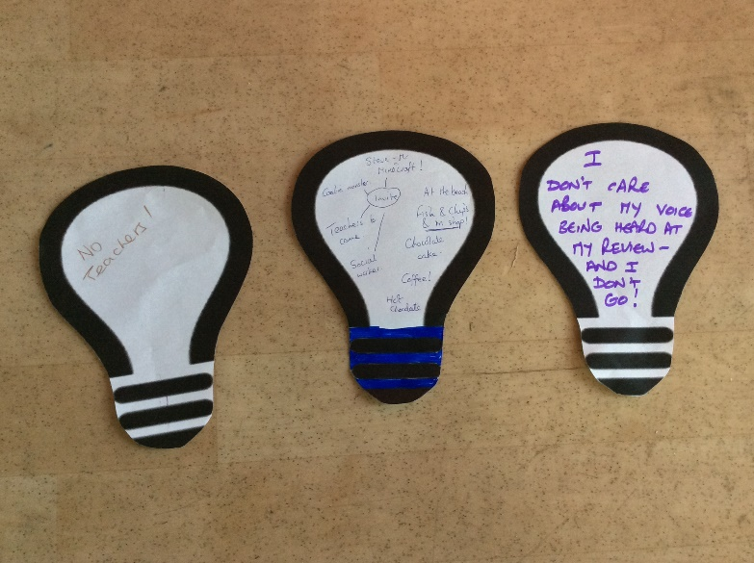  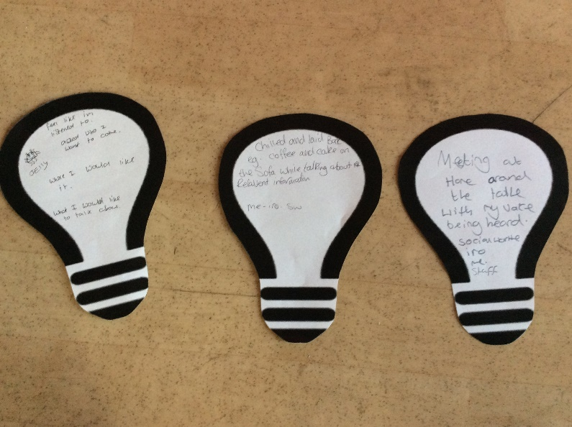  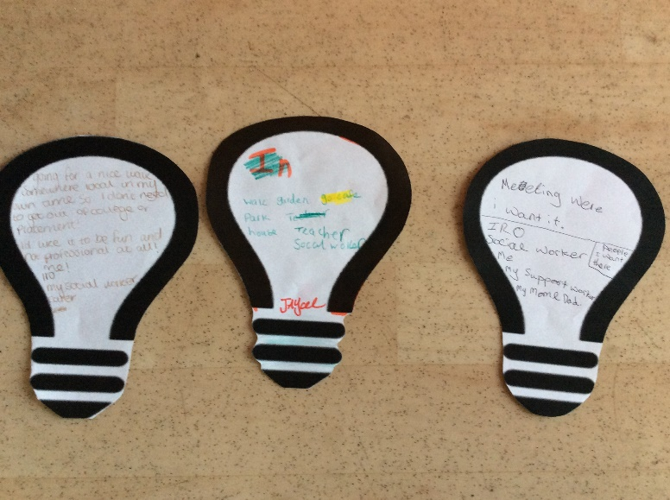  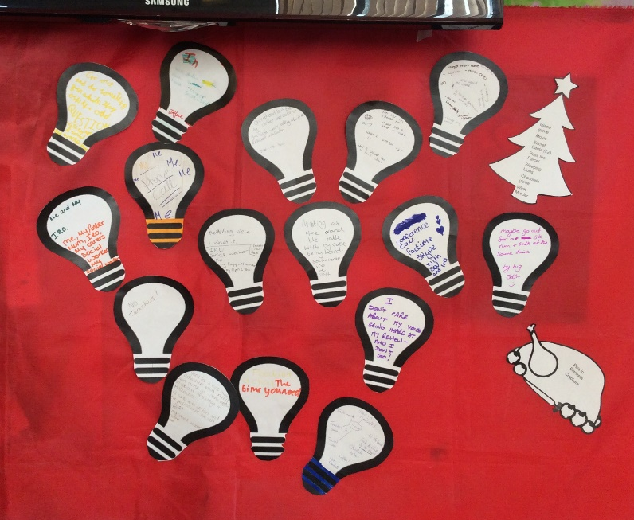  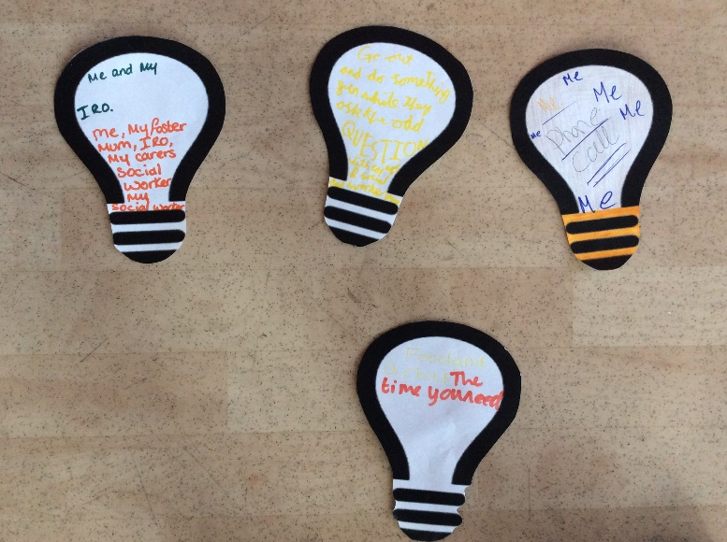 | Liz will use the information to change the CLA review process and feedback to the group in the new year.
 | Break for lunch with everyone playing a part either in preparing, setting up, washing up or clearing away.
6. | Activity
 | Becca led the group in a game of charades.
7. | Dates
Lesley quickly ran through upcoming dates, Corporate Parenting Board, Animation filming & SiCC SLCC Christmas party.

All agreed they would form their own corporate parenting group and only these people would attend, they would then feedback to the group.

8. | Virtual School – In Care in School
 | Carrying from last month’s meeting where the group thought about how they would like to get the messages about being in care to schools. The group identified the + & - about each way.  I.e. the positives and negatives about displaying posters, using business cards, leaflets, display boards etc.  Young people also shared one message they would like to share with schools.  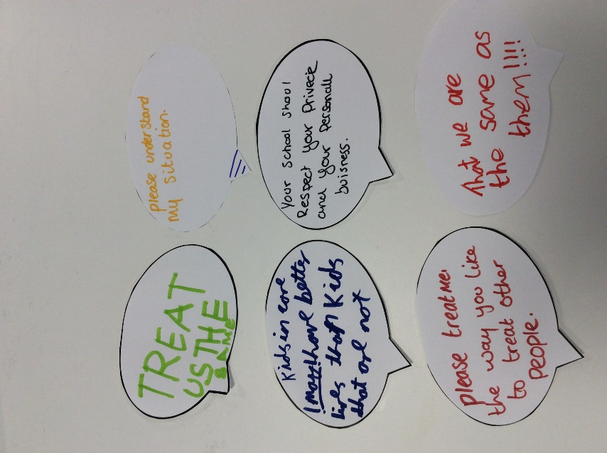  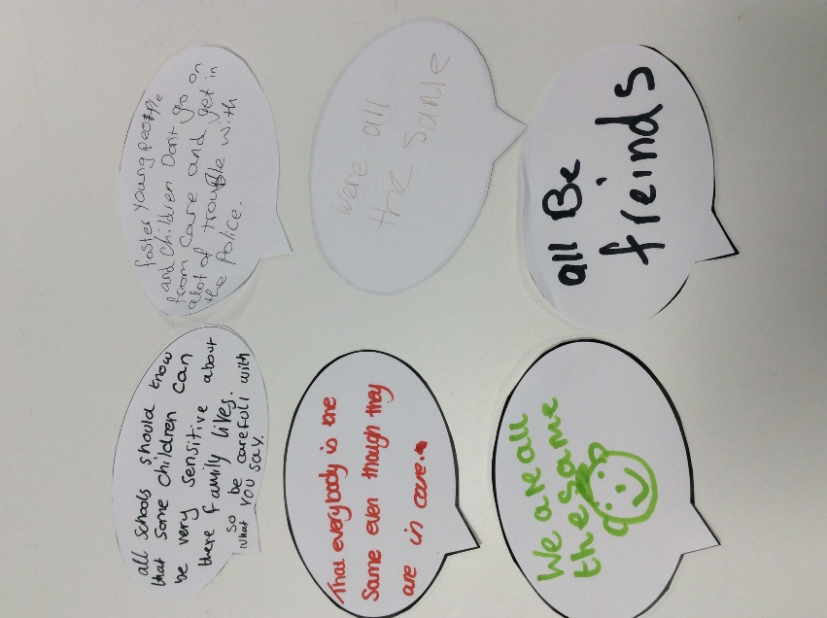  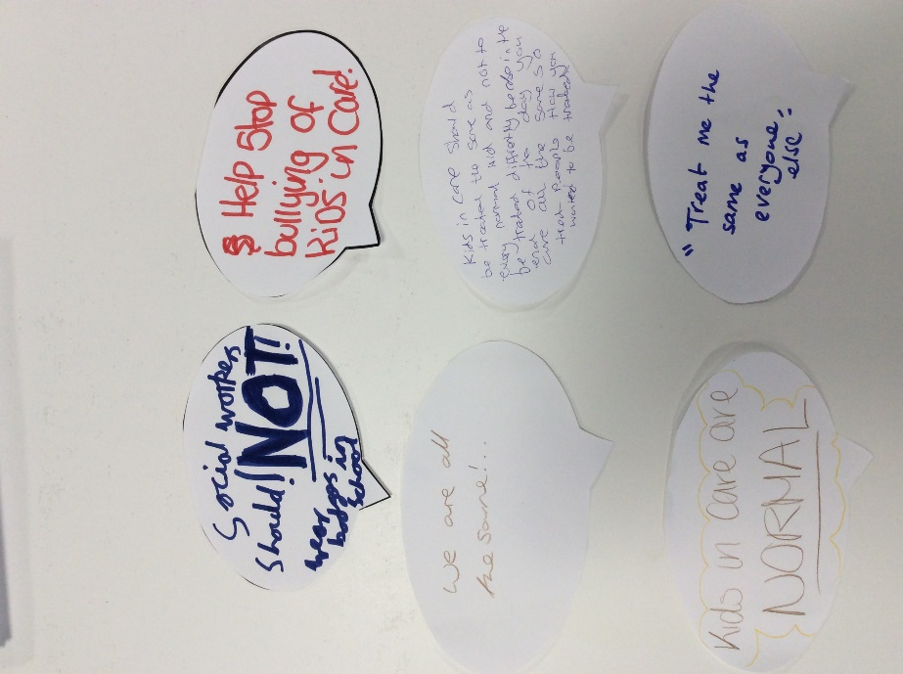 | Lesley to write up ready for January’s meeting &  Lesley to write up and add to last months messages.  school project to remain a standing agenda item.
9 | Christmas Party Ideas
 | 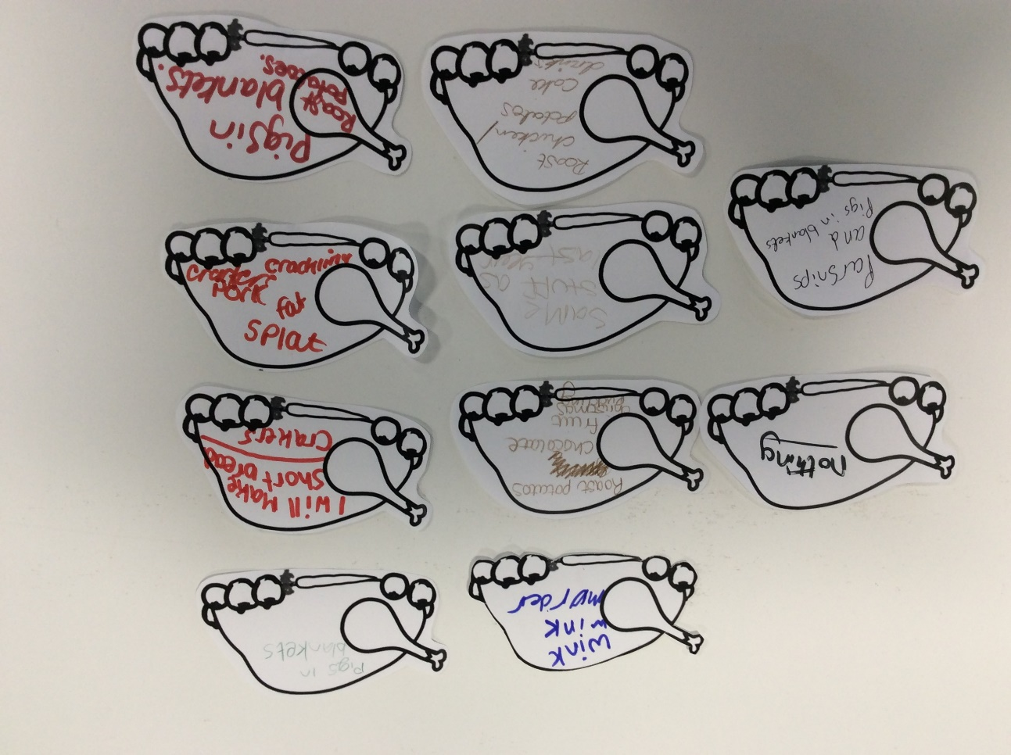 | Lesley to add to last month’s ideas and party plan.

